2020年CTCC中国房车锦标赛
超级杯车型注册表-副表1 官方指定产品注册表
2020 China Touring Car Championship
HOMOLOGATION FORM FOR MODLE IN SUPER CUP
-APPENDIX 1 OFFICIAL PARTS

车型注册号码/HOMOLOGATION NUMBER

CTCC-XXX-2001-YYY-ZZZ-A

官方指定产品注册号码/OFFICIAL PARTS HOMOLOGATION NUMBER

CTCCKS-XXX-YYY-ZZZ-2001

注册人/APPLICANT

XXX

注册有效期/ HOMOLOGATION VAILD

2020年

审核人/AUDIT SIGNATURE
姓名  签字 | 姓名  签字 | 姓名  签字

1. 一般项目/ GENERAL

1.1. 制造商/ MANUFACTURER

填写/Description

1.2. 车型和类型/ MODEL AND TYPE
a）车型和类型/ Model and type | 填写/Description
b）车架号码/ Typical chassis number | 填写/Description

2. 发动机/ ENGINE

2.1. 涡轮增压器/ TURBOCHARGING
a）品牌和型号/ Make and model |  | Owen GBT-GTCC17
b）排气涡轮壳体/ Turbine housing |  | b1）废气出口数量  Number of exhaust gas entries |  | 1
 |  | b2）材质  Material |  | D5S- Ni Resist
c）排气涡轮/ Turbine wheel |  | c1）材质  Material |  | Inco 713c
 |  | c2）叶片数  Number of blades |  | 9

c3）根据草图A,B,C,D的尺寸

Dimensions A, B, C, D according to the sketch

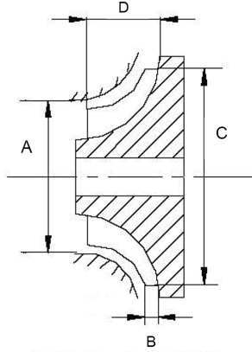

A=47.9±0.3mm B=8.46±0.3mm

C=54.4±0.2mm D=22.6±0.5mm

d）叶轮（压缩机）壳/ Impeller housing |  | d1）进气口数量（混合）  Number of air entries (mixture) |  | 1
 |  | d2）材质  Material |  | 铝
e）压缩机涡轮/ Impeller wheel |  | c1）材质  Material |  | 铝锻磨
 |  | c2）叶片数  Number of blades |  | 7+7 mixed height = 14

c3）根据草图A,B,C,D的尺寸

Dimensions A, B, C, D according to the sketch

A=49.85 ±0.3mm B=3.94 ±0.3mm

C=68 ±0.2mm D=22.43 ±0.3mm

g）排气系统/ Exhaust system
g1）歧管和涡轮增压器之间管道的内部尺寸  Internal dimensions of the possible pipes between manifold and turbocharger |  |  |  | 填写/Description±2mm

h）进气冷却/ Exhaust system
h1）有无/Yes or No | 有/Yes 单项勾选/Single choice |  | 无/No单项勾选/Single choice
h2）系统/System | 空气/Air
h3）中冷器欣型号Make and model of intercooler core | 空气/Air

I2-1）排气侧涡轮壳的进气口 I2-2）排气侧涡轮壳的出气口
Exhaust gas inlet to the turbine housing Exhaust gas outlet from the turbine housing
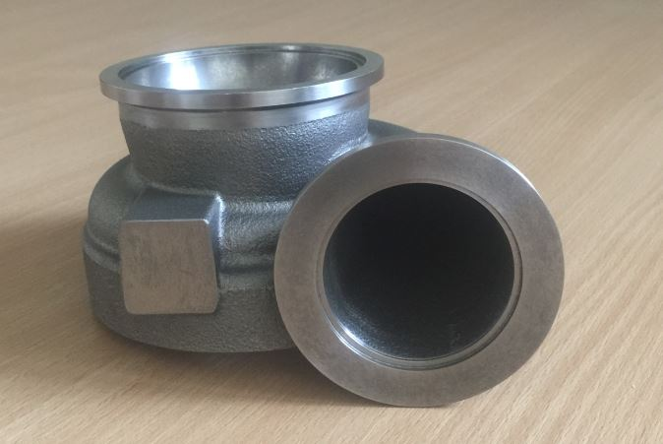 | 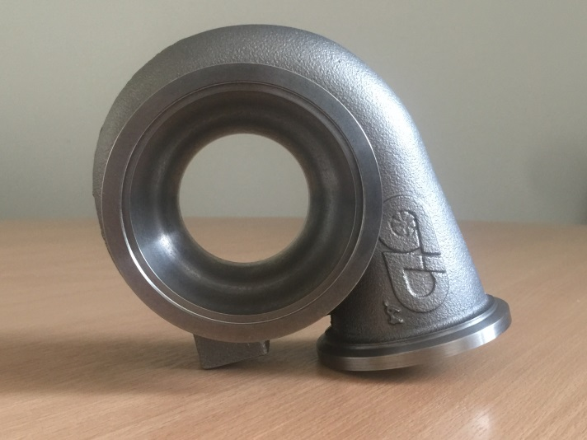
I2-3）压缩机外壳空气（气）进口 I2-4）压缩机外壳空气（气）出口
Air (gas) inlet to the compressor housing Air (gas) outlet from the compressor housing
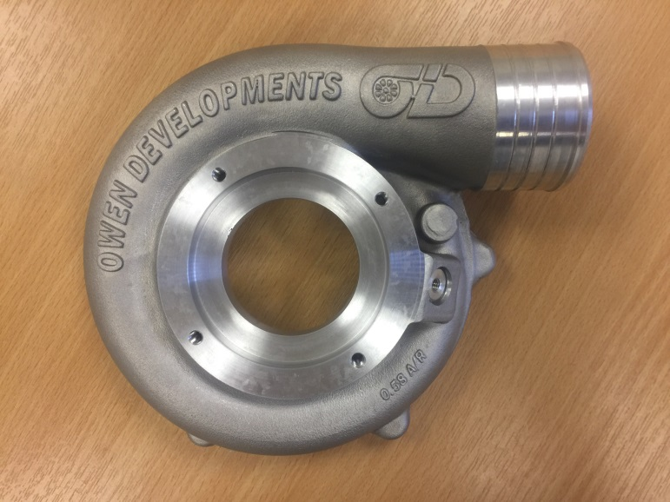 | 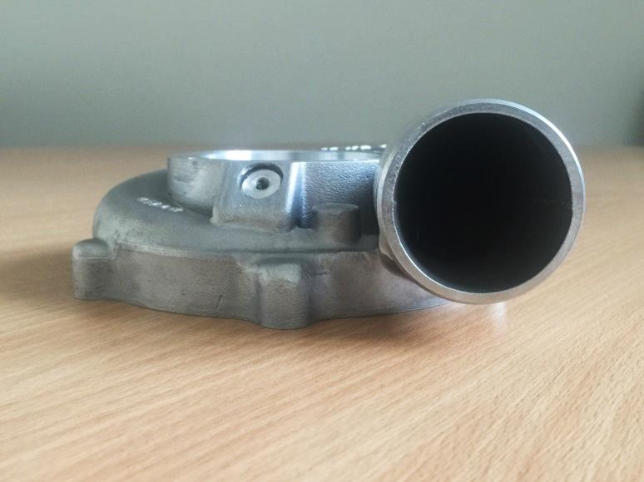

P2-1）完整的涡轮增压器单元的主视图 P2-2）完整的涡轮增压器单元的前视图
Plan view of complete turbocharger unit Front view of complete turbocharger unit
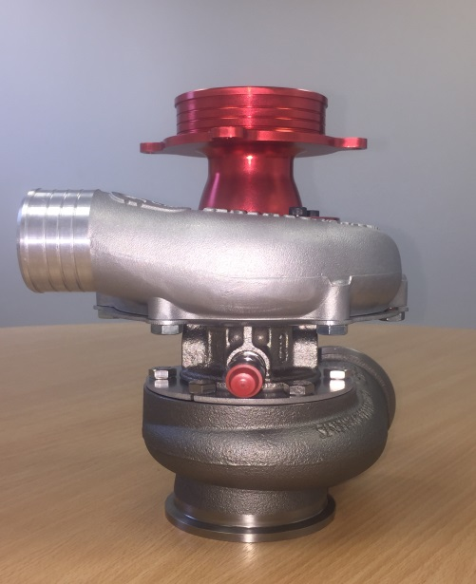 | 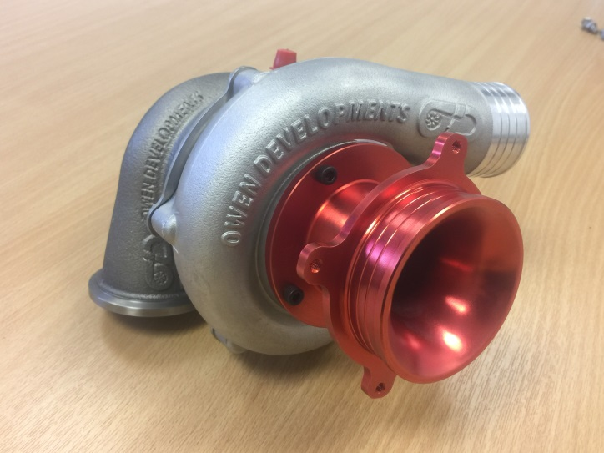
P2-3）完整的涡轮增压器单元的侧视图 P2-4）涡轮增压器压缩机壳 – 拆下状态
Side view of complete turbocharger unit Compression housing of turbocharger
– dismounted
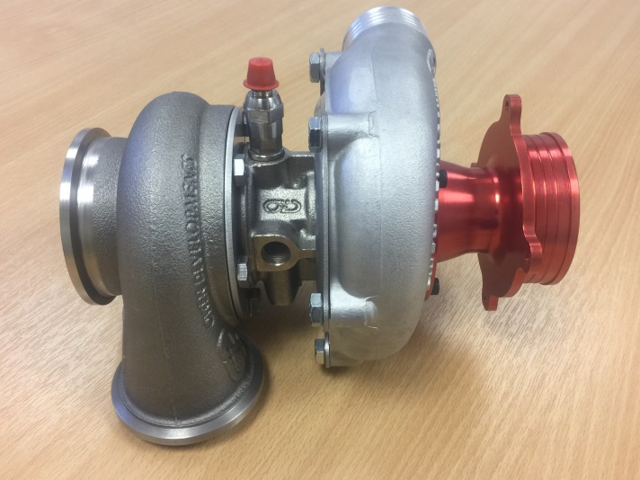 | 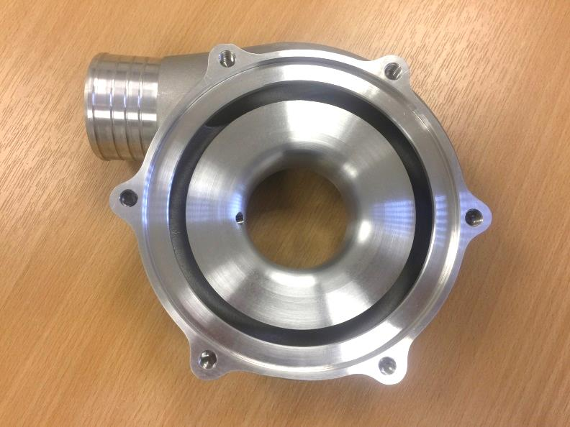

P2-5）涡轮增压器的涡轮壳 – 拆下状态 P2-6）中冷器芯 – 拆下状态
Turbine housing of turbocharger Intercooler core – dismounted
– dismounted
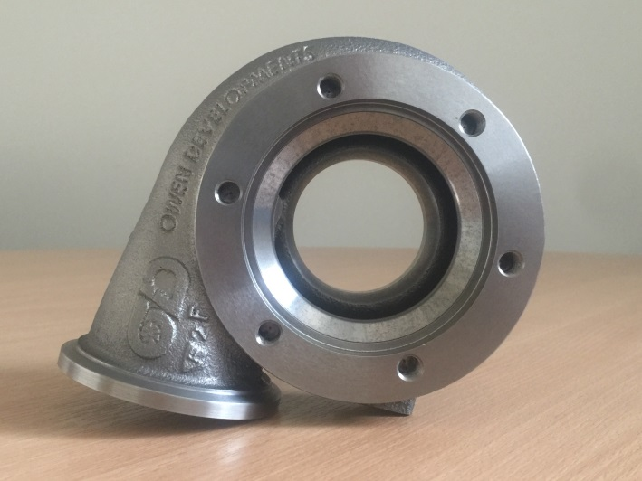 | 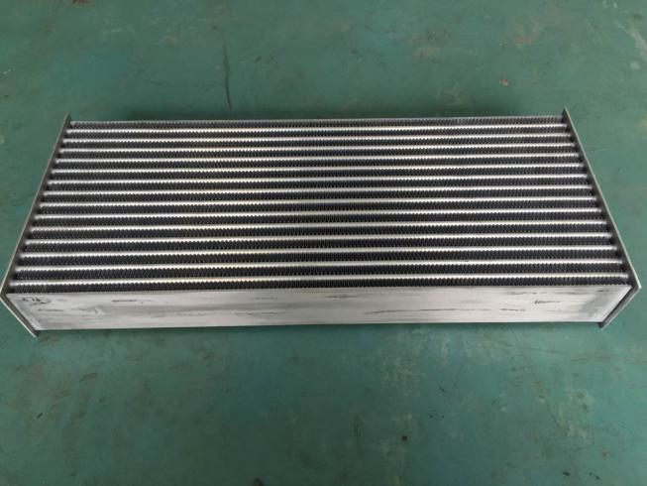
I2-5）中冷器芯尺寸的绘图（长x宽 x厚）
Drawing of the intercooler core with dimensions of core (Width x Height x Thickness)

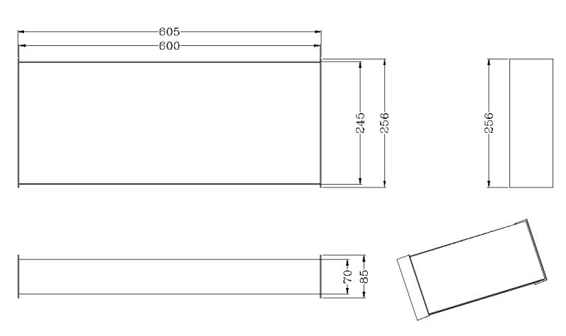

3. 燃油系统/ FUEL CIRCUIT

3.1. 油箱/ FUEL TANK
a）品牌和型号/ Make and model | MERIN  SFT 4214 (bladder), SFT 4348 (cover) | 单项勾选  Single choice
 | ATL  FB115(bladder), SU115(cover) | 单项勾选  Single choice
b）数量/Number | 1
c）材质/Material | 防爆材料
d）总容量/ Total capacity | 60 ±3升/Litres
e）注油孔位置/ Location of filler holes | 填写/Description
P3-1）油箱（MERIN） – 拆下状态 P3-2）油箱（ATL） – 拆下状态
Fuel tank（MERIN） – dismounted Fuel tank（ATL） – dismounted
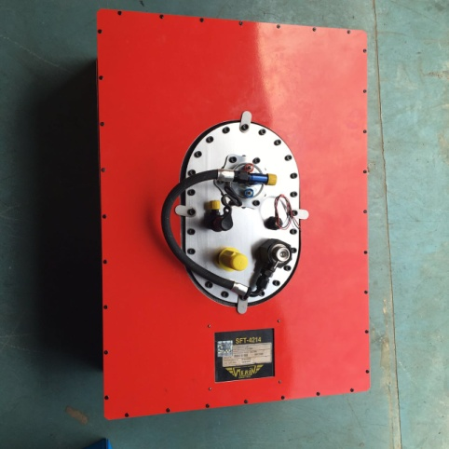 | 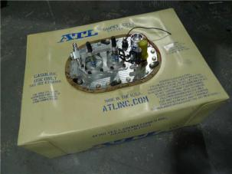

3.2. 油泵/ FUEL PUMPS
a）高压油泵/Main pump | Bosch 058025044
b）低压油泵/Lift pump | AC E06442520

4. 传动系统/ POWER TRAIN

4.1. 变速箱/ GEARBOX
a）品牌和型号/ Make and model | 3MO ETCW |  | 单项勾选/Single choice
 | Xtrac P1262 / P1546B |  | 单项勾选/Single choice
b）注册速比  *注：请填入”减速比“，即输出侧齿数除以输入侧齿数得到的数值，并精确到小数点后3位。  例：输入侧齿数为16，输出侧齿数为37，则其减速比为37/16=2.313 | 齿轮减速比 / Gear Reduction Ratio
 | 第1套 / SET 1 | 第2套 / SET 2
b1）一档/First gear | 填写/Description | 填写/Description
b2）二档/Second gear | 填写/Description | 填写/Description
b3）三档/Third gear | 填写/Description | 填写/Description
b4）四档/Forth gear | 填写/Description | 填写/Description
b5）五档/Fifth gear | 填写/Description | 填写/Description
b6）六档/Sixth gear | 填写/Description | 填写/Description
P4-1）变速箱和离合器外壳（3MO） P4-2）变速箱和离合器外壳（Xtrac）
Gearbox casing and clutch bell housing Gearbox casing and clutch bell housing
（3MO） （Xtrac）
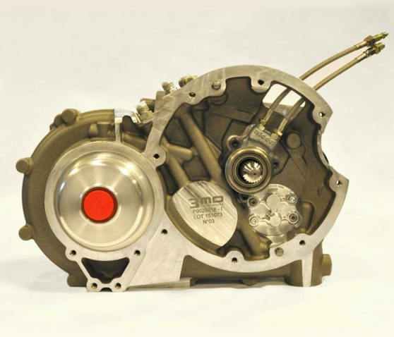 | 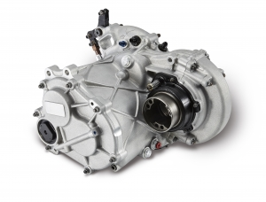

4.2. 主减速器/ FINAL DRIVE
a）主减速器类型/ Type of final drive | 变速箱内置/built-in | 单项勾选/Single choice
 | 后驱外置/RWD external | 单项勾选/Single choice
b）品牌和型号（如外置）  Make and model（if external） | 填写/Description
c）主减速比  Reduction ratio of final drive  *注：请填入“减速比”，即输出侧齿数除以输入侧齿数得到的数值，并精确到小数点后3位。 | 填写/Description
P4-3）主减速器外壳（如外置）
Final drive casing (If external)

Photo

添加照片

P4-4）差速器总成（3MO） P4-5）差速器 - 分解（3MO）
Differential assembly （3MO） Differential dismantled（3MO）
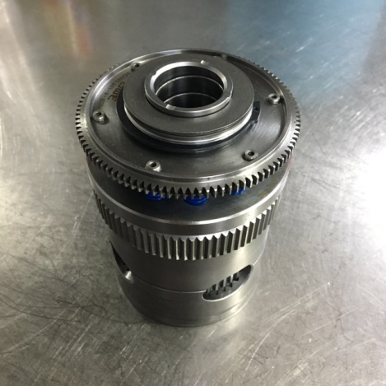 | 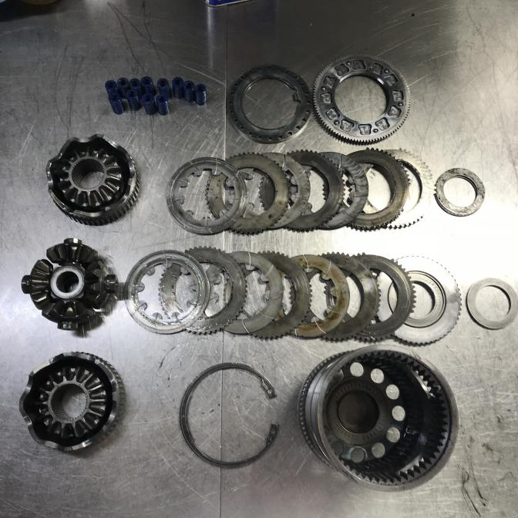
P4-6）差速器总成（Xtrac） P4-7）差速器 - 分解（Xtrac）
Differential assembly （Xtrac） Differential dismantled（Xtrac）
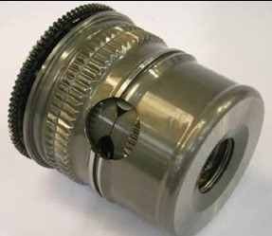 | 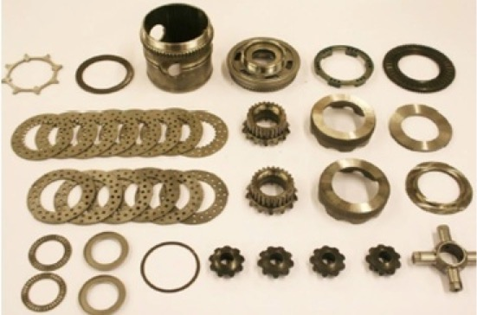

4.3. 传动轴/ DRIVESHAFT
传动轴型号/ Driveshaft model | B130-G3000 | 单项勾选/Single choice
 | B180-G3000 | 单项勾选/Single choice
 | B180-G4000 | 单项勾选/Single choice

4.4. 离合器/ CLUTCH
a）离合器压盘/ Clutch Pressure Plate | Alcon KKS1842UDGSR01/02
b）离合器片/ Clutch Plate | Alcon KDS720FA30X001/003

5. 行走装置/ RUNNING GEAR

5.1. 前制动/ FRONT BRAKES
a）制动卡钳型号  Model of Brake calipers | 前轮 / FRONT
 | 类型1 / TYPE 1 | 类型2 / TYPE 2
 | CAR8949Y18SSLL/RL | CR6440/（LL.RL）-BAT
 | 单项勾选/Single choice | 单项勾选/Single choice
a1）缸径  Bore | 27/31.8/38.1 ±0.1mm | 27/31.8/38.1 ±0.1mm
a2）每缸轮数  Number of cylinders per wheel | 6 | 6
a3）每个车轮刹车片数量  Number of pads per wheel | 2 | 2
a4）每个车轮卡钳数量  Number of calipers per wheel | 1 | 1
a5）卡钳材质  Caliper material | 铝合金 | 铝合金
a6）每个刹车片的长度  Overall friction length of each pad | 151.9 ±1.5mm | 151.9 ±1.5mm
b）刹车盘型号  Model of Brake disk | DIV2202X910S36L/R
b1）新刹车盘厚度  Thickness of new disc | 36 ±1mm
b1b）刹车盘的最小厚度（最大磨损）  Min. thickness of disc (max. wear) | 34 mm
b2）刹车盘外部直径  External diameter of disc | 380 ±1.5mm

b3）摩擦表面的外径  External diameter of pads'rubbing surface | 380 ±1.5mm
b4）摩擦表面的内径  Internal diameter of pads'rubbing surface | 260 ±1.5mm
b5）通风碟  Ventilated discs  通风道数量  Number of venting channels | 是/Yes | √ | 否/No | 单项勾选  Single choice
 | 36
b6）新盘最小重量（带连接盘和螺钉）  Min. weight of new disc (with bell and screws) | 9220 g
P5-1）前制动卡钳 - 类型1 P5-2）前制动卡钳编号标签 - 类型1
Front brake caliper type 1 Front brake caliper label - type 1
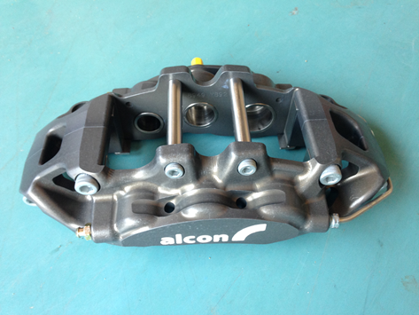 | 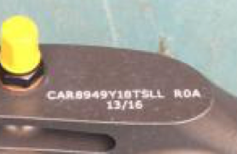

P5-3）前制动卡钳 - 类型2 P5-4）前制动卡钳编号标签 - 类型2
Front brake caliper type 2 Front brake caliper label - type 2
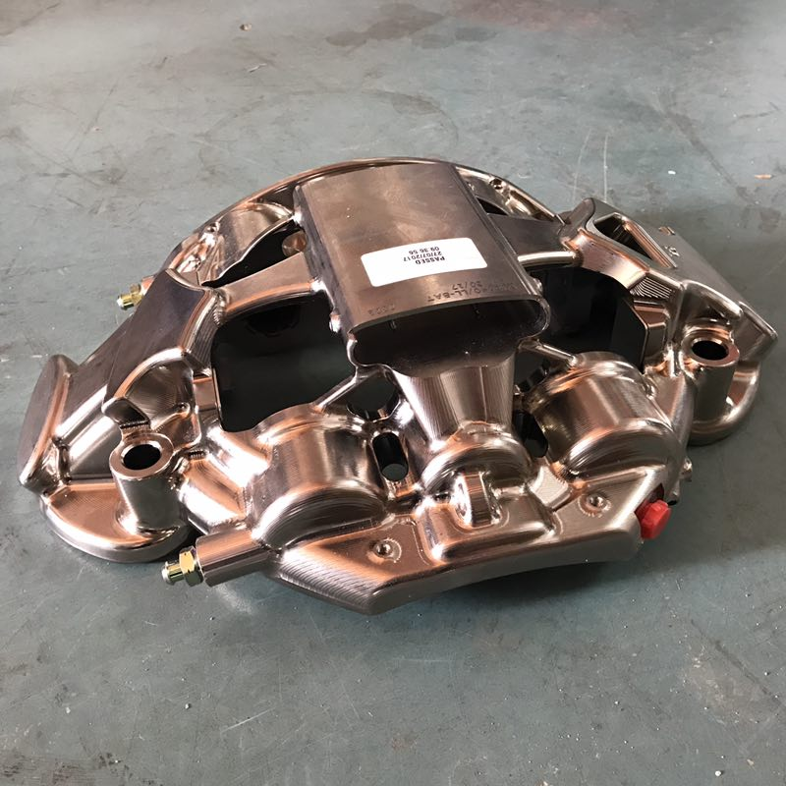 | 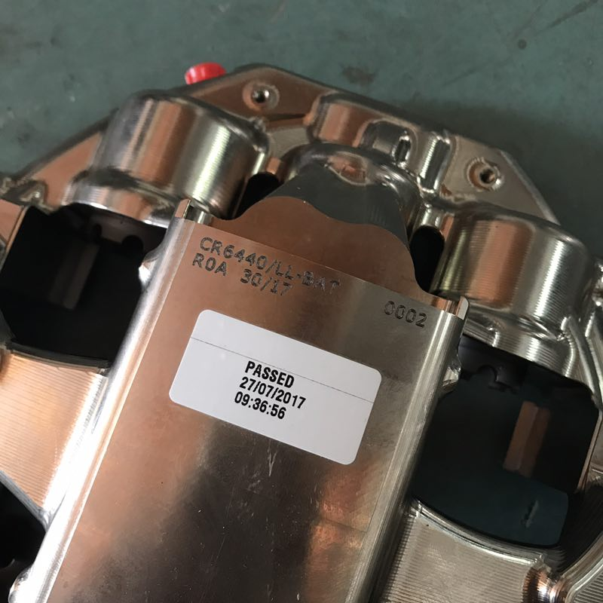
P5-5）前刹车盘 P5-6）前刹车盘
Front brake disk Front brake disk
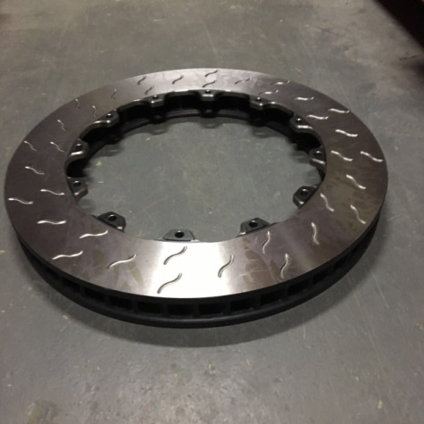 | 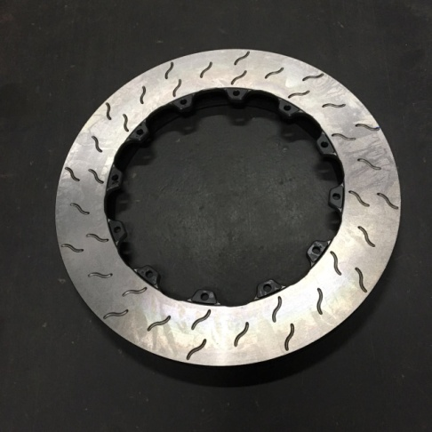

5.2. 后制动/ REAR BRAKES
a）制动卡钳型号  Model of Brake calipers | 后轮 / REAR
 | CAR0649A01/06ASLL/RL
a1）缸径  Bore | 28.6 ±0.1mm
a2）每缸轮数  Number of cylinders per wheel | 2
a3）每个车轮刹车片数量  Number of pads per wheel | 2
a4）每个车轮卡钳数量  Number of calipers per wheel | 1
a5）卡钳材质  Caliper material | 铝合金
a6）每个刹车片的长度  Overall friction length of each pad | 52.4 ±1.5mm
b）刹车盘型号  Model of Brake disk | DIS1907X073S24
b1）新刹车盘厚度  Thickness of new disc | 10 ±1mm
b1b）刹车盘的最小厚度（最大磨损）  Min. thickness of disc (max. wear) | 8 mm
b2）刹车盘外部直径  External diameter of disc | 300 ±1.5mm
b3）摩擦表面的外径  External diameter of pads'rubbing surface | 300 ±1.5mm
b4）摩擦表面的内径  Internal diameter of pads'rubbing surface | 170 ±1.5mm

b5）通风碟  Ventilated discs  通风道数量  Number of venting channels | 是/Yes | 单项勾选  Single choice | 否/No | √
 | 0
b6）新盘最小重量（带连接盘和螺钉）  Min. weight of new disc (with bell and screws) | 3650 g
P5-7）后制动卡钳 P5-8）后制动卡钳编号标签
Rear brake caliper Rear brake caliper label
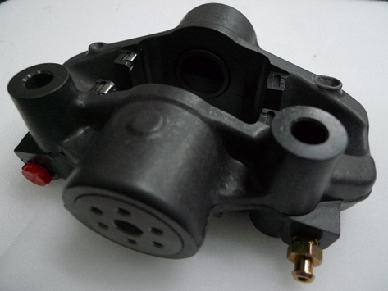 | 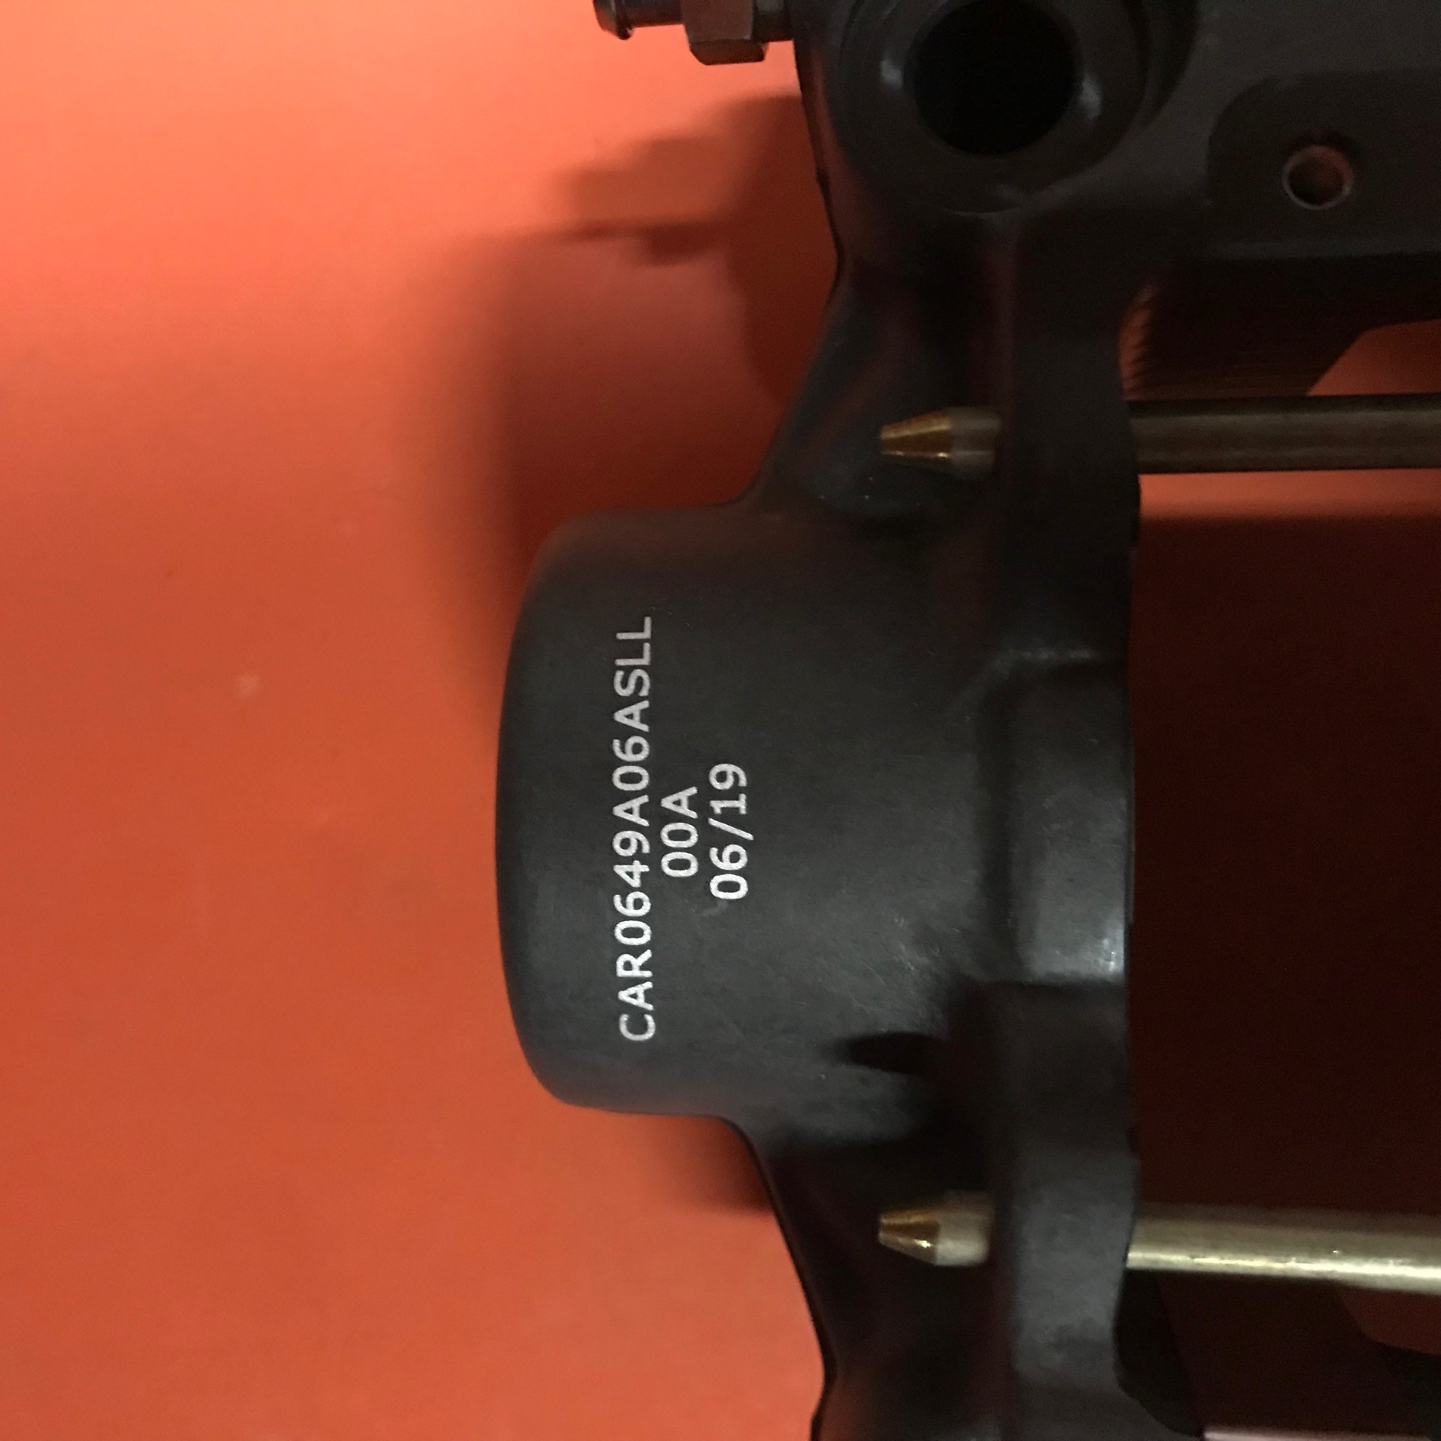
P5-9）后刹车盘 P5-10）后刹车盘
Rear brake disk Rear brake disk
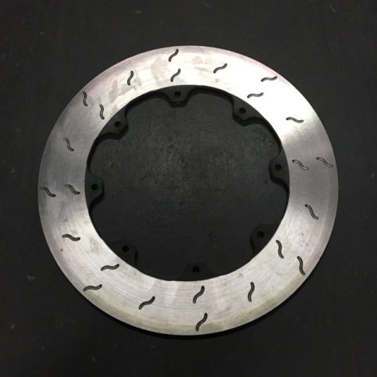 | 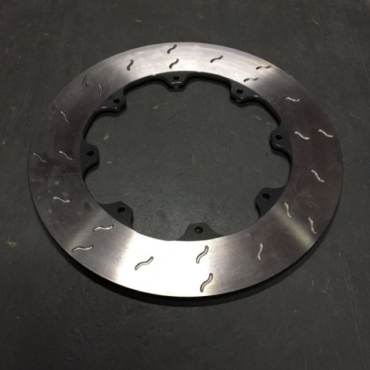

5.3. 转向/ STEERING
a）品牌和型号/ Make and model | RML P130-K4410
P5-11）转向机 - 拆下状态/ Steering mechanism - dismounted

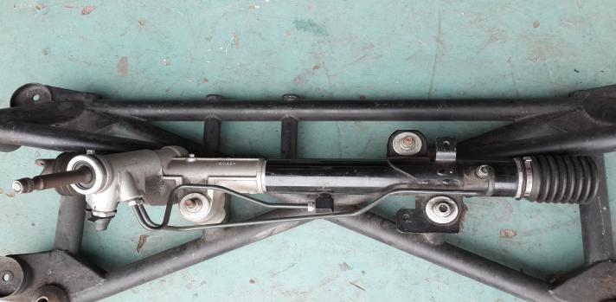
P5-12）转向机 - 编号标签/ Steering mechanism - label

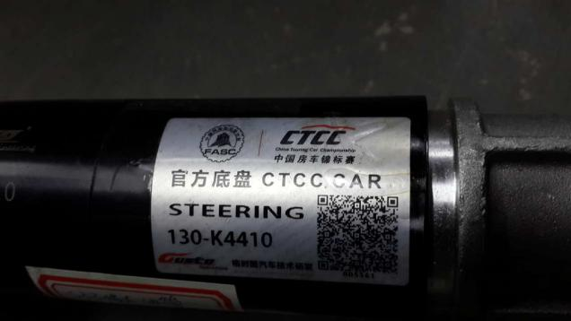

5.4. 避震器/ DAMPERS
a）品牌和型号/ Make and model | Ohlins CTF 5N00/6N00 | 单项勾选/Single choice
 | KW Competition 3way | 单项勾选/Single choice

采用KW Competition 3way避震器时，车架部分避震器塔顶轴承座如下：

P5-13）避震器塔顶轴承座 – 拆下状态 P5-14）避震器塔顶轴承座 – 编号标签
Housing BRG damper - Dismounted Housing BRG damper - Label
Photo  添加照片 |  | Photo  添加照片
产品编号/Part No. | 填写/Description | 最小重量/Min. weigh | 填写/Description g

采用KW Competition 3way避震器时，车架部分避震脚如下：
P5-15）避震脚 – 拆下状态 I5-1）避震脚 – 图
Damper bracket - Dismounted Damper bracket - Drawing
Photo  添加照片 |  | Drawing  添加图纸
材质/Material |  | 填写/Description
产品编号/Part No. | 填写/Description | 最小重量/Min. weigh | 填写/Description g

5.5. 轮圈/ RIMS
a）品牌和型号/ Make and model | Aspec MF75 CTCC
b）材质/ Material | 6061_T6
c）制造工艺/ Manufacturing process | 锻造
d）轮圈尺寸/ Rim size | 18×10.0J
e）螺栓孔节圆直径/ PCD | 5×112
f）偏距/ ET | 25
g）中心孔/ CB | 70.2
H）重量/ Weight | 8.96 kg ±0.2kg
P5-16）轮圈 – 拆下状态，正面 P5-17）轮圈 – 拆下状态，背面
Rim - Dismounted，front view Rim - Dismounted，rear view
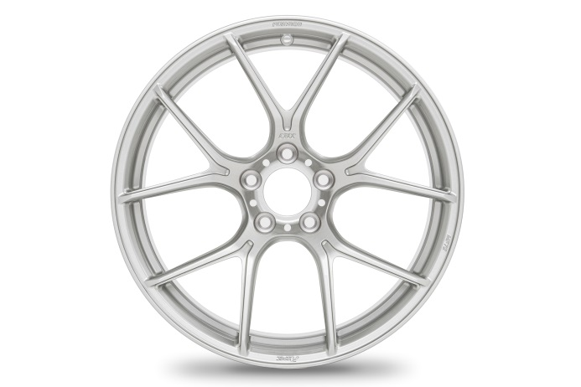 | 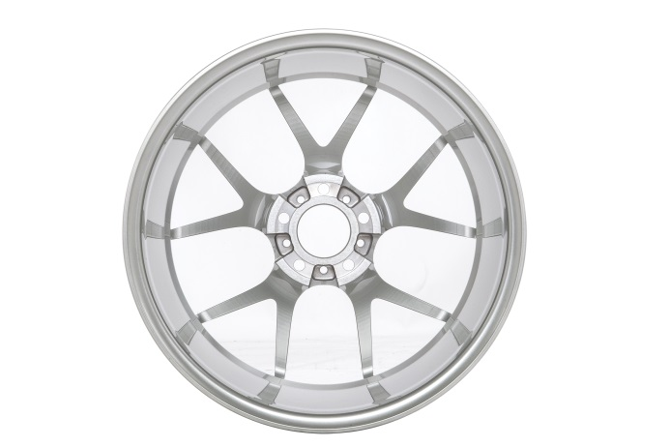

P5-18）轮圈 – 拆下状态，侧面 P5-19）轮圈 – 编号标签
Rim - Dismounted，side view Rim - label
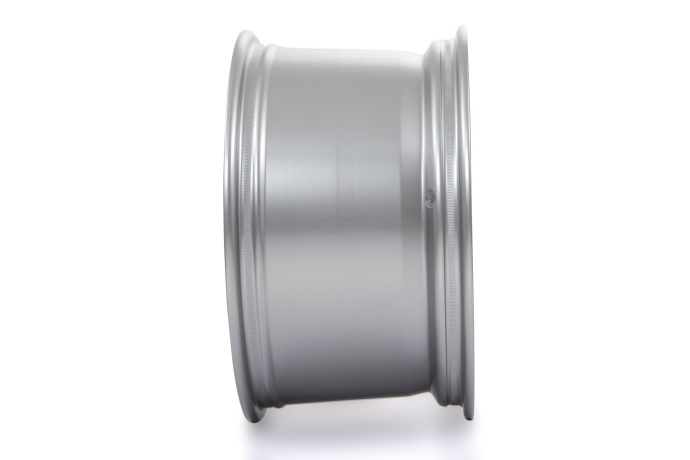 | 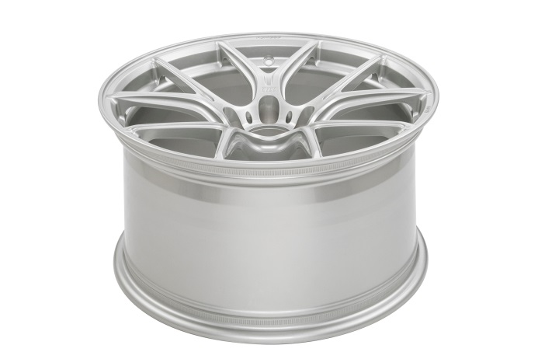

6. 电子系统/ ELECTRONICS SYSTEM

6.1. 发动机控制单元/ ENGINE ECU
a）品牌和类型/ Make and type | Bosch Motorsport | 直接/Direct
b）型号/ Model | MS 6.3
b1）软件/ Software | MS6A_BASE_0900

6.2. 电源分配模块/ POWER DISTRIBUTION UNIT
a）品牌和类型/ Make and type | Bosch Motorsport
b）型号/ Model | PBX 90
b1）软件/ Software | PBX_BASE_0235

6.3. 仪表显示单元/ DASHBOARD DISPLAY UNIT
a）品牌和类型/ Make and type | Bosch Motorsport
b）型号/ Model | DDU 9
b1）软件/ Software | DDU9_BASE_0410

6.4. CAN开关面板/ CAN SWITCH PANEL
a）品牌和类型/ Make and type | Bosch Motorsport
b）型号/ Model | CK-M12

